Hamza
24k-3065
Lab-08
Task-2
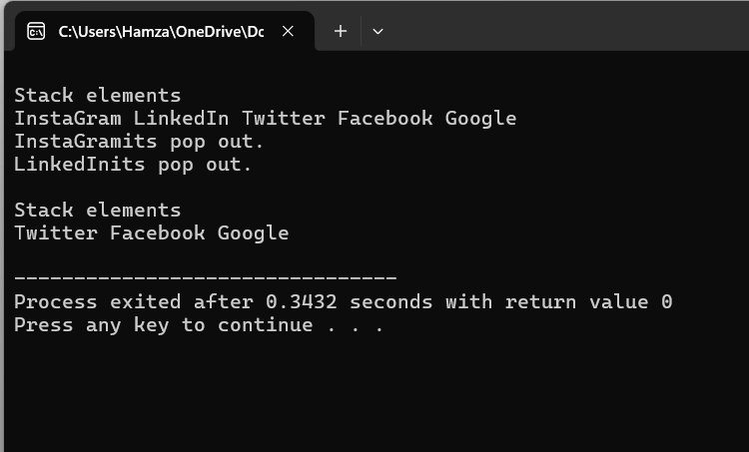
#include<iostream>
using namespace std;

class Node{
public:
string data;
Node* next;

Node(string value){
data=value;
next=NULL;
}
};

class Stack{
Node* top;
public:
Stack(){
top=NULL;
}

void push(string value){
Node* newNode=new Node(value);
newNode->next=top;
top=newNode;

}

void pop(){
if(isEmpty()){
cout<<"Stack is Empty.";
}
Node* temp=top;
cout<<temp->data<<"its pop out."<<endl;
top=top->next;
delete temp;
}
bool isEmpty(){
if(top==NULL){
return true;
}
return false;
}
void display(){
if(isEmpty()){
cout<<"Stack is empty.";
return;
}
Node* temp=top;
cout<<"\nStack elements"<<endl;
while(temp!=NULL){
cout<<temp->data<<" ";
temp=temp->next;
}
cout<<endl;
}
};

int main(){
Stack s;
s.push("Google");
s.push("Facebook");
s.push("Twitter");
s.push("LinkedIn");
s.push("InstaGram");
s.display();
s.pop();
s.pop();
s.display();

}
Task-5
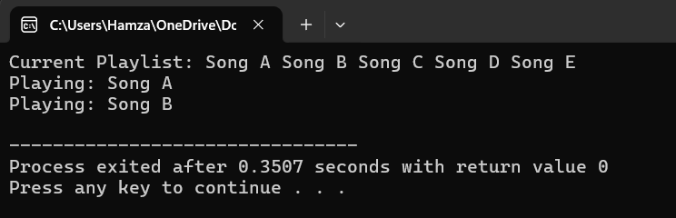
#include<iostream>
using namespace std;

class CircularQueue{
string s[5];
int front,rear;
int capacity;

public:
CircularQueue(){
front=0;
rear=-1;
capacity=5;

}
void addsongs(string value){
rear=(rear+1)%capacity;
s[rear]=value;
}
void playNext(){
if(isEmpty()){
cout<<"No songs to play";
return ;
}
cout<<"Playing: "<<s[front]<<endl;
front=(front+1)%capacity;
}
bool isEmpty(){
if(capacity==0){
return true;
}
return false;
}
void display(){
if (isEmpty()) {
cout << "Playlist is empty.\n";
return;
}
cout<<"Current Playlist: ";
int i=front;
for(int j=0;j<capacity;j++){
cout<<s[i]<<" ";
i=(i+1)%capacity;
}
cout<<endl;
}
};
int main(){
CircularQueue c;
c.addsongs("Song A");
c.addsongs("Song B");
c.addsongs("Song C");
c.addsongs("Song D");
c.addsongs("Song E");
c.display();
c.playNext();
c.playNext();

}
Task-6
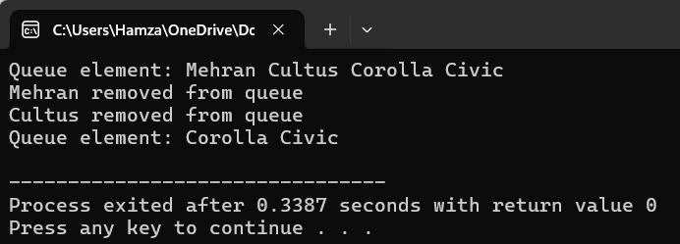
#include<iostream>
using namespace std;

class Queue{
string s[10];
int rare;
int front;
public:
Queue(){
front=0;
rare=-1;
}
void enqueue(string value){
if(rare>=9){
cout<<"Queue Overflow"<<endl;
return;
}
rare++;
s[rare]=value;
}
void dequeue(){
if(rare<0){
cout<<"Queue UnderFlow"<<endl;
return;
}
cout<<s[front]<<" removed from queue"<<endl;

for(int i=front;i<rare;i++){
s[i]=s[i+1];
}
rare--;
}
bool isEmpty(){
if(rare<front){
return true;
}
return false;
}
void display(){
if(isEmpty()){
cout<<"Queue is Empty"<<endl;
return;
}
cout<<"Queue element: ";
for(int i=front;i<=rare ;i++){
cout<< s[i]<<" ";
}
cout<<endl;
}
};
int main(){
Queue q;
q.enqueue("Mehran");
q.enqueue("Cultus");
q.enqueue("Corolla");
q.enqueue("Civic");
q.display();
q.dequeue();
q.dequeue();
q.display();
}

